Program sample output:

**% java quakes –top5**

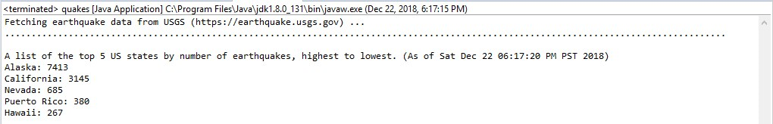

**% java quakes --NH**

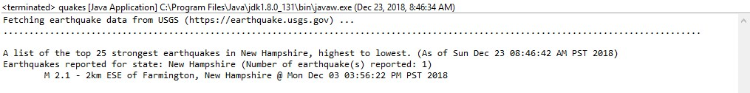

**% java quakes –WV**

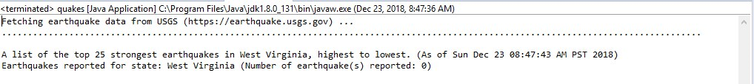

**% java quakes --NC**

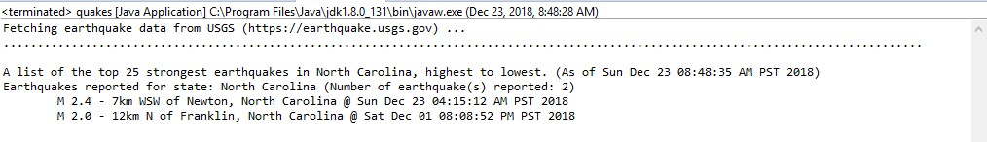**% java quakes --California**

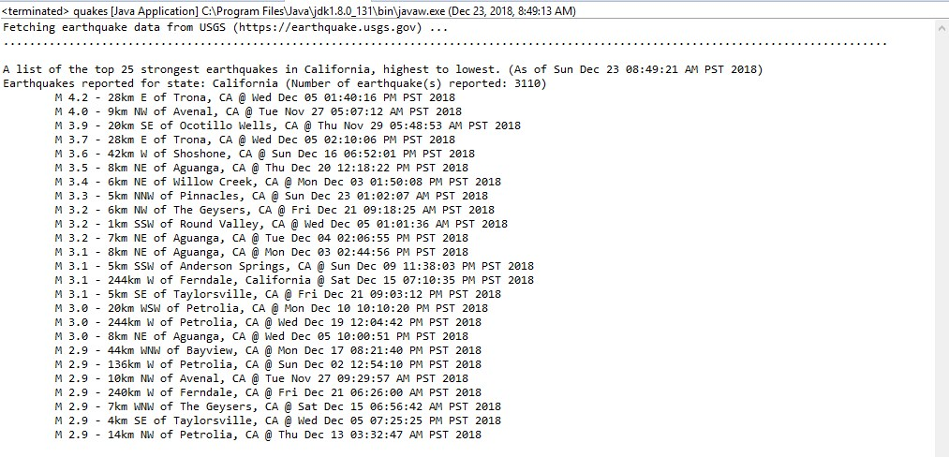

**% java quakes –Alaska**

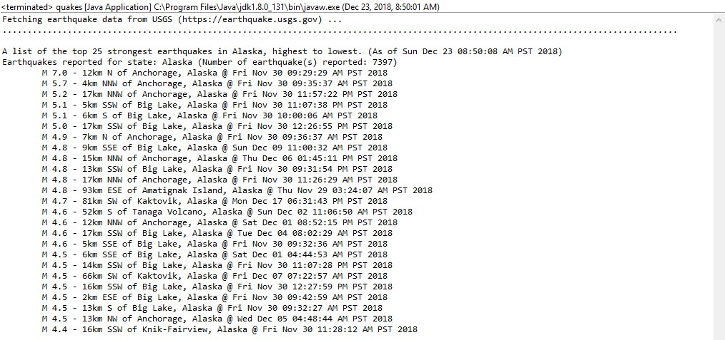

**% java quakes –statestop5**

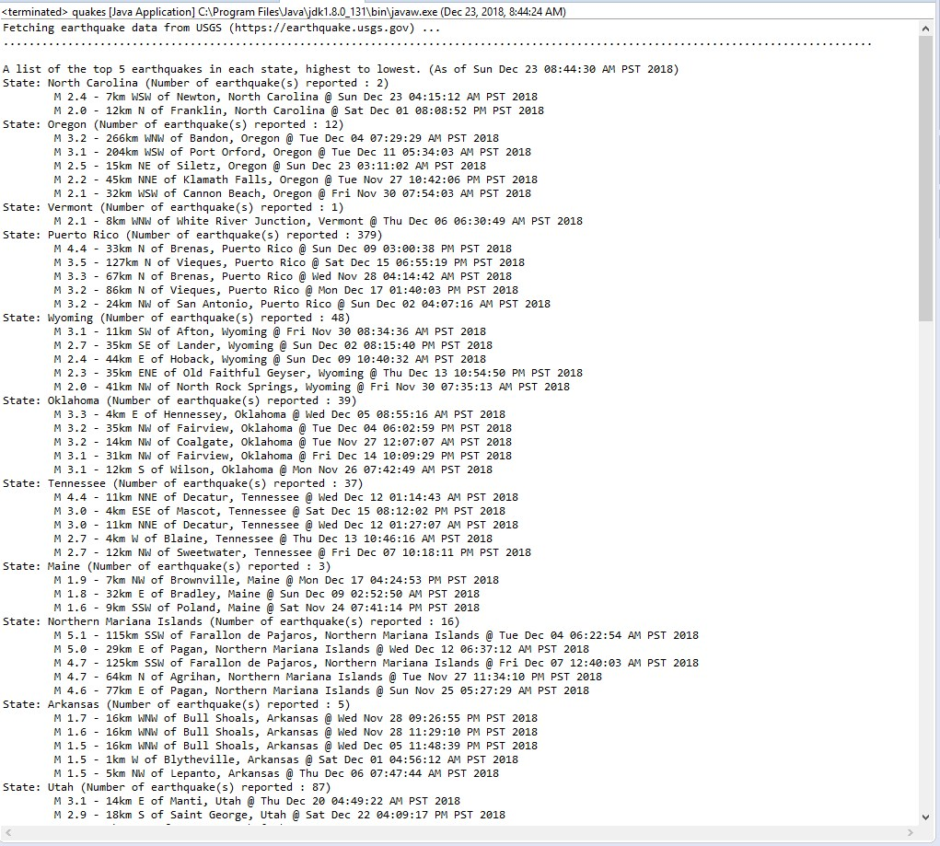

**% java quakes –**

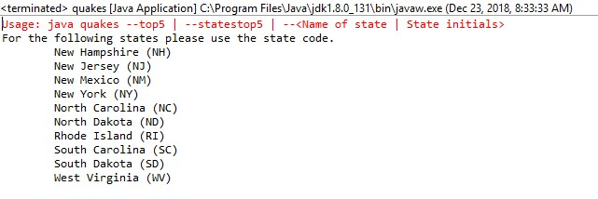

**% java quakes –top**

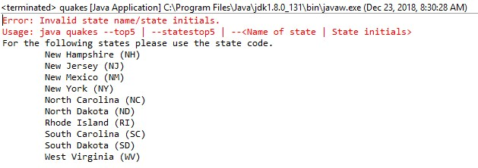

**% java quakes –Alask**

